DAFTAR HADIR MAHASISWA KULIAH KHUSUS

PERIODE SIDANG BULAN ………. 20 ….

SEMESTER GASAL/GENAP TAHUN AKADEMIK 20 … / 20 …

NAMA DOSEN :

MATA KULIAH :

|  |  |  |  |  |  |  |  |  |
| --- | --- | --- | --- | --- | --- | --- | --- | --- |
| NO | N P M | NAMA MAHASISWA | PERKULIAHAN | | | | | TOTAL |
| 1 | 2 | 3 | 4 | 5 |
| 1 |  |  |  |  |  |  |  |  |
| 2 |  |  |  |  |  |  |  |  |
| 3 |  |  |  |  |  |  |  |  |
| 4 |  |  |  |  |  |  |  |  |
| 5 |  |  |  |  |  |  |  |  |

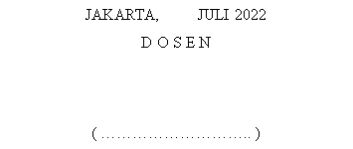

JAKARTA, JULI 2022

D O S E N

( ……………………….. )

)

JAKARTA, JULI 2022

D O S E N

(KHALIDA UTAMI, S.E., M.Sc)

)

JAKARTA, JULI 2022

D O S E N

(KHALIDA UTAMI, S.E., M.Sc)

)

JAKARTA, JULI 2022

D O S E N

(KHALIDA UTAMI, S.E., M.Sc)

)